Arduino Lesson 21
PS2 Joystick
PS2 Joystick generally can be used to control the car, and so on, its structure is mainly two 10 k potentiometer and a key switch.

5 Posts are VCC，X，Button，Y，GND。
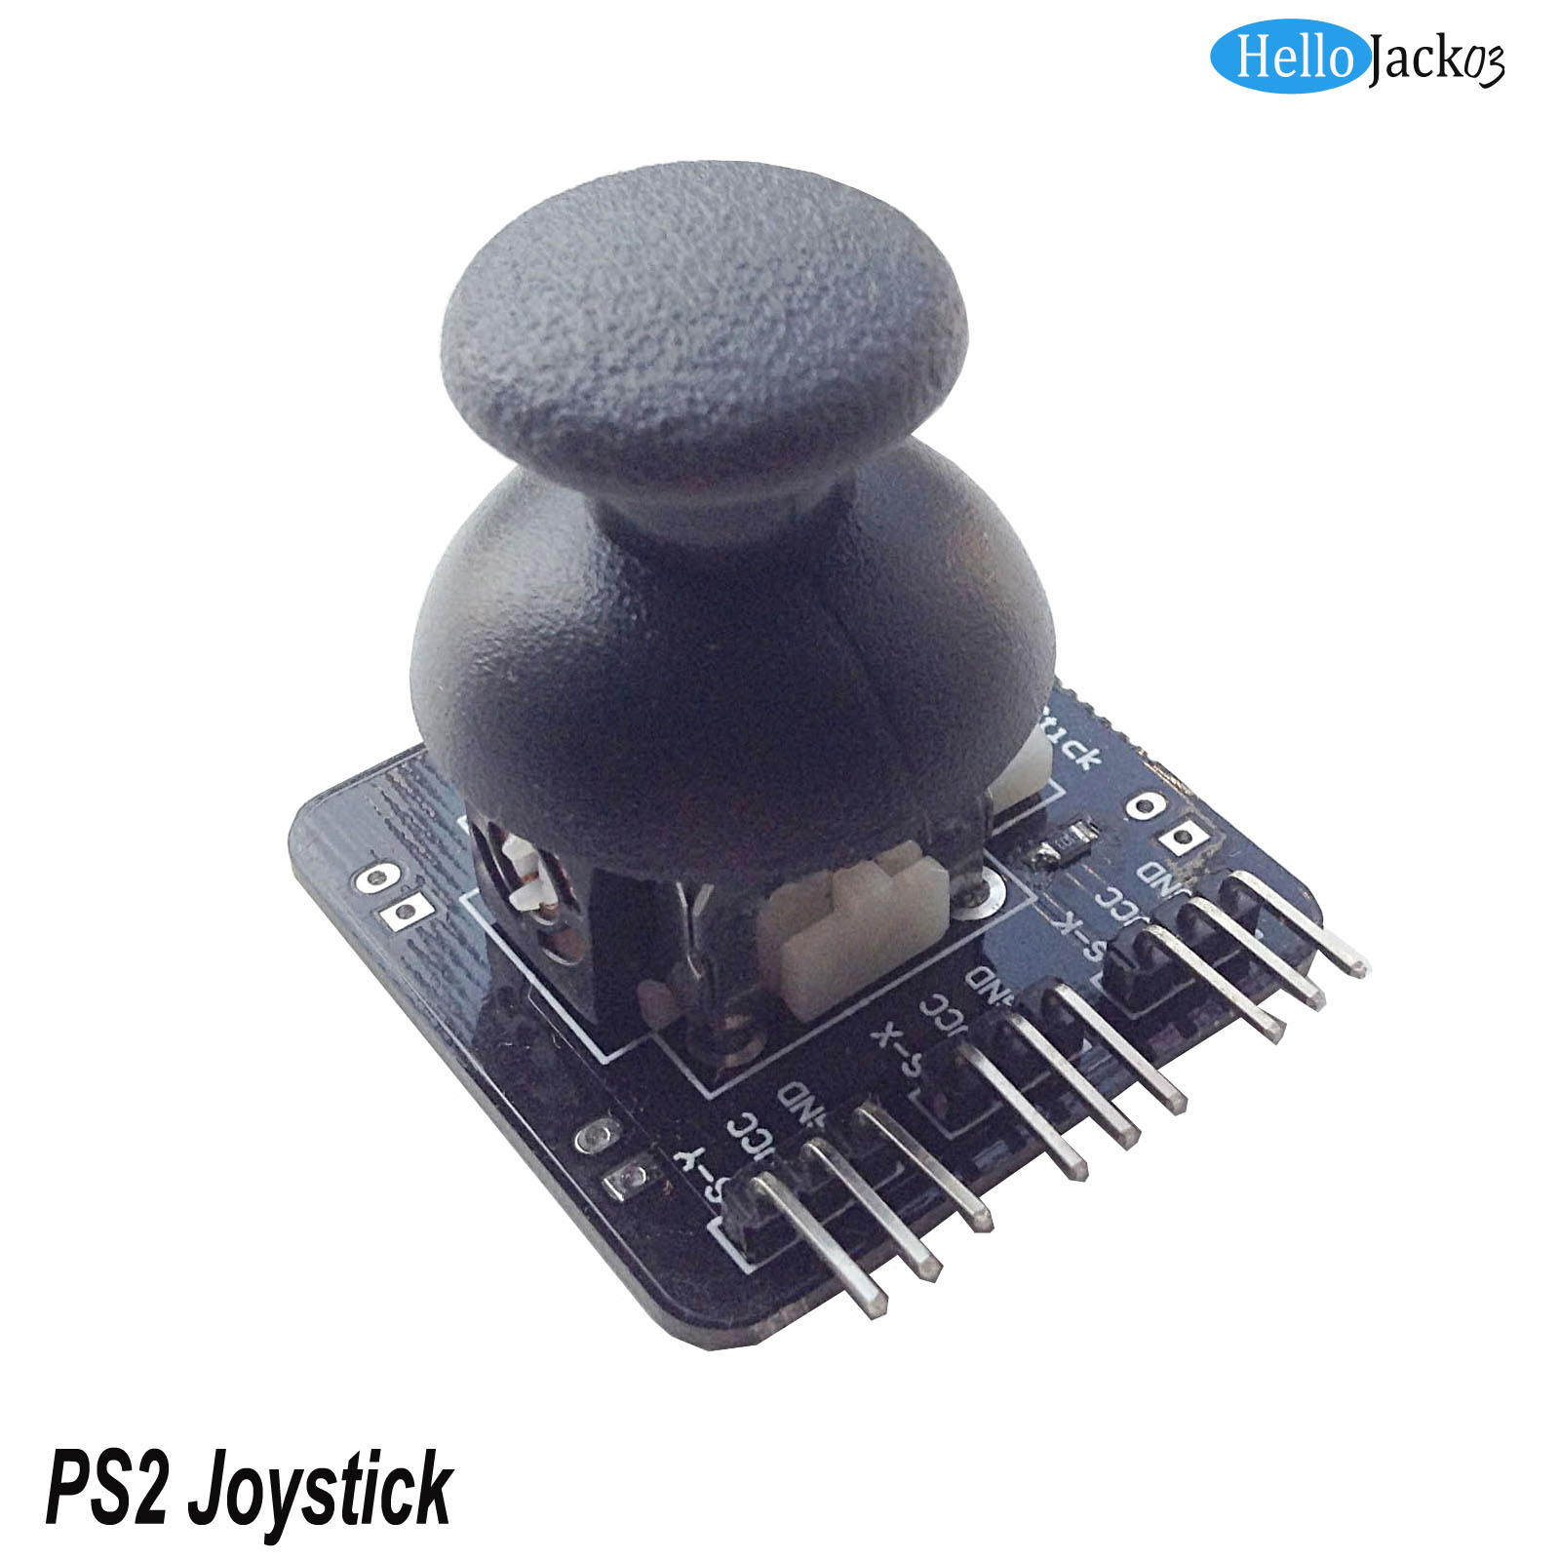

- Connect-it-up
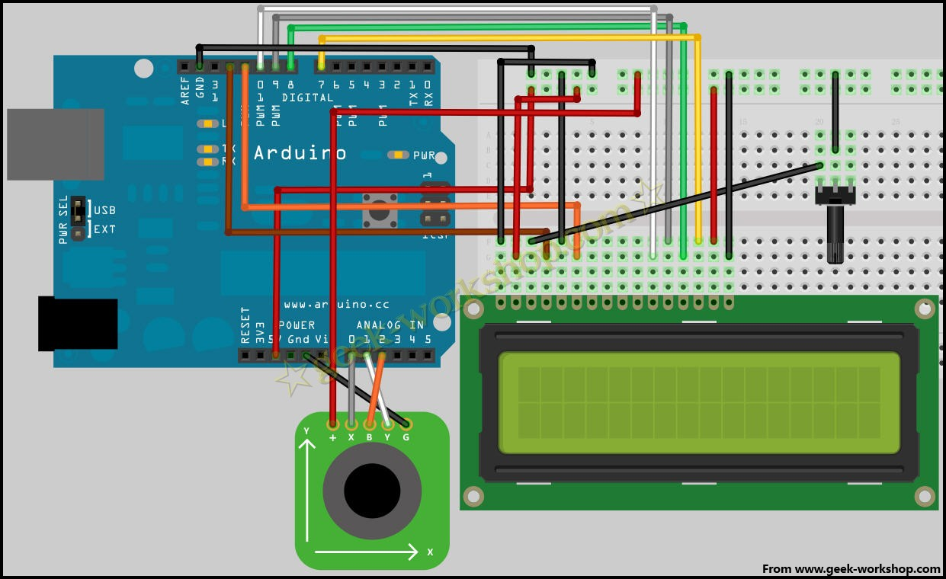

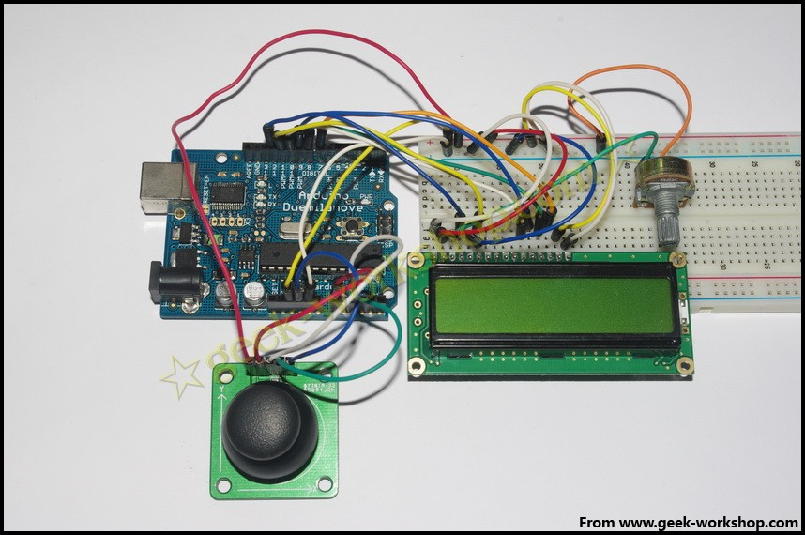

- Code for reference
- #include <LiquidCrystal.h> // invoking arduino build-in LiquidCrystal library

- LiquidCrystal lcd(12, 11, 10, 9, 8, 7);//Set up interface

- int xpotPin = 0; //Set up analog port #0 as signal input port for “x”
- int ypotPin = 1; // Set up analog port #1 as signal input port for “Y”
- int bpotPin = 2; // Set up analog port #2 as signal input port for “button”

- int xval=0; //set up variable
- int yval=0;
- int bval=0;

- void setup()
- {
- lcd.begin(16, 2); // initialize LCD
- delay(1000); //delay 1000ms
- }

- void loop ()
- {

- xval = analogRead(xpotPin); //xval variable
is the reading from #0.
- yval = analogRead(ypotPin); // Yval variable
is the reading from #1.
- bval = analogRead(bpotPin); //bval variable
is the reading from #2.
- lcd.clear(); //clear
- lcd.setCursor(0, 0) ; //设置光标位置为第一行第一个位置
- lcd.print("X="); //make lcd display X=
- lcd.print(xval);
- lcd.setCursor(7, 0) ; //设置光标位置为第一行第八个位置
- lcd.print("Y="); // make lcd display Y=
- lcd.print(yval);

- if (bval<500)
- {
- lcd.setCursor(0, 1) ; //设置光标位置为第二行第一个位置
- lcd.print("Button ON"); // make lcd display Button ON
- }
- else
- {
- lcd.setCursor(0, 1) ;
- lcd.print("Button OFF"); // make lcd display Button OFF
- }

- delay(100); //delay 0.1秒

- }

- Set up analog port #0 as signal input port for “x”
- Set up analog port #1 as signal input port for “Y”
- Set up analog port #2 as signal input port for “button”
- set up variable

- Set cursor position to the first line of the first position

- Set cursor position for the first line of the eighth position

- Set cursor position to the second line of the first position

Push the joystick, the potentiometer resistance changes, the corresponding voltage change, also the Numbers in the LCD screen is digital output of each shaft voltage. Press the button, button state on the LCD display changes.

